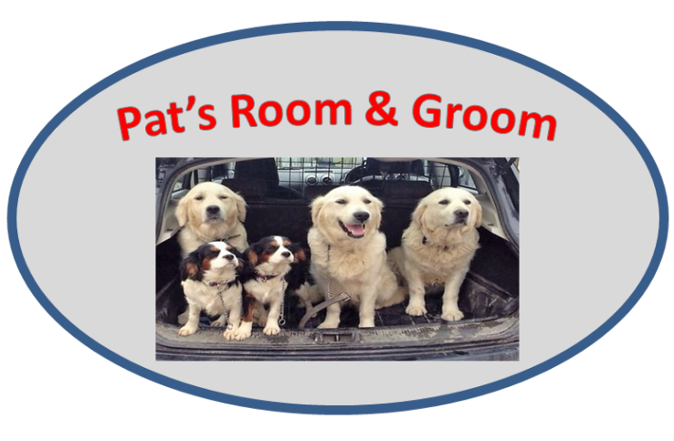

Owner: _________________ Contact No: ______________ E-mail: ___________________
Dog 1 Name: ____________________ Breed: ___________ Sex: Male/Female
Neutered: Yes/No Licence: Yes/No Age: ___________
Dog 2 Name: ____________________ Breed: ___________ Sex: Male/Female
Neutered: Yes/No Licence: Yes/No Age: ___________
Vet (Name/Practice): ______________________________ Contact No: ________________
Grooming: (Following only necessary if grooming is required)
Is it ok to shave big mats that are painful to brush out? Yes/ No
Is it ok to go shorter all over due to matting? Yes/ No

Please give a brief description of your grooming requirements:
______________________________________________________________________________________________________________________________________________________

Boarding/Day Care:(Following only necessary if boarding/day-care is required)
Boarding from Date: _______ Time:______ to Date:_______ Time:______

Collection/ Delivery required: Yes/ No

Feeding: Frequency: _________ Quantity: _________ Wet/Dry: _____

Sleeping: Standard or Premium
Individual or Multiple (sleeps with company of other dogs)

Do you wish your dog to socialise with other dogs during the day? Yes/ No
Are all your dog’s vaccinations up to date? Yes/ No
Has your dog(s) been vaccinated for Kennel Cough? Yes/ No
Does your dog currently have any medical/medication requirements? Yes/ No
(if yes give details below)

I agree that my dog may be recorded on camera and its images may be used for Pat’s Room & Groom promotional material. Yes/ No

Additional Comments:
____________________________________________________________________________________________________________________________________________________________________________________________________________________________________________________________________________________________________________

Disclaimer

This grooming, day-care and/or boarding disclaimer is used in conjunction with Pat’s Room & Groom’s contract with customer for services and is made as part of that contract and is incorporated by reference for all purposes. This document need only be signed once by the customer and covers all future customers’ pets at this facility.

- I confirm that my dog is up to date with all vaccinations and that my dog is healthy to the best of my knowledge.

- If my pet is hurt or becomes ill, Pat’s Room & Groom (PR&G) has permission to call or take my pet to a vet, administer medication or give advisable attention at their discretion. I accept that these expenses are my responsibility.

- PR&G reserve the right to charge additional fees for special requests they consider to be over and above the norm covered by their standard rates. They also reserve the right to refuse service to customers whose pet may pose a threat to them or to the other pets in their care.

- I understand that incidents of injury may occur from playing with the other dogs, which may include bites, scratches and sprains. PR&G will not be held responsible for any sickness/ injury caused by the pet to itself during boarding/ day-care/ grooming.

- I confirm that my dog is sociable and has not harmed or shown threatening behaviours towards any person or any other dog. I understand PR&G reserves the right to remove my dog from the communal exercise areas and place my dog in a separate area should my dog display any unwanted behaviours.

- PR&G is not responsible for any accidental death or death from a natural disaster (fire storm, flood etc).

- I accept that any medication being left for my dog to be administered by PR&G and any effects of this medication on my dog is my responsibility.

- I accept that every effort will be made by PR&G to ensure the safety of my dog while in its care. Notwithstanding this, in the event of escape or theft PR&G will not be held responsible for same.

- I agree to pick up my dog prior to 7pm. I understand that dogs picked up after this time may incur an additional fee.

- Cancellation and no-show policy:
PR&G’s policy is that clients who are unable to make their appointment give us as much advance notice as possible.

As a grooming client at PR&G I accept the following conditions in addition to the above.

- I accept that all due care will be taken for the safety of the dog and the groomer. I am aware that neglect of my dog’s coat may be a cause of problems after grooming such as clipper/ brush irritations. If my dog does not remain still during grooming, accidents can happen such as nicks/scrapes from clippers or scissors.

- If deemed necessary, PR&G may need to de-mat my dog, which will incur additional charge to the standard fee. I understand that time and costs associated with de-matting are unpredictable and subject to the particular condition of the dog.

With my signature below I certify that I have read and understand the agreement and waivers. I agree to abide by the regulations and accept all terms and conditions as set out.

Signature: _________________________ Date:_________________________

